Fav Subject – Digital Electronics and Data Analytics
Practical going on around the electronics industry.

DATA Analytics
Analytics is the science of analyzing raw data to derive actionable insights and conclusions.

What are types of Data Analytics
Descriptive Analytics – Describe what has happened
Predictive Analytics – Statistical Model and machine learning to predict the probability of the outcome.
Prescriptive Analytics – What should happen? Gives the most appropriate steps that should be taken.
Diagnostic – Why it happened?

Process of Data Analytics:
- What is question – Take a clearly defined steps to go answer the hypotheses.
- Gather the data
- Clean the data
- Analyse the data
- Draw insights from Data

What is statistics
Statistics is the science concerned with developing and studying methods for collecting, analyzing, interpreting and presenting empirical data. (Basically Data analytics)

What is hypothesis testing?
Hypothesis testing is an act in statistics whereby an analyst tests an assumption regarding a population parameter.

What is null hypotheses
The null hypothesis states that a population parameter (such as the mean, the standard deviation, and so on) is equal to a hypothesized value
Or – There is no difference between the hypothesised value and actual outcome.
Alternate Hypotheses
The alternative hypothesis states that a population parameter is smaller, greater, or different than the hypothesized value in the null hypothesis.
What is type 1 ?
A type I error - when a null hypothesis is rejected, even though it should not be rejected.
A type I error is "false positive" leading to an incorrect rejection of the null hypothesis.
and type 2 error?
A type II error is a error that occurs when one fails to reject a null hypothesis that is actually false.
A type II error produces a false negative.
Q-Define level of significance?
Statistical significance refers to the claim that a result from data generated by testing or experimentation is not likely to occur randomly or by chance but is instead likely to be attributable to a specific cause.
What is Regression
The relationships between a dependent variable and one or more independent variables.
Cluster Analysis
Cluster analysis or clustering is the task of grouping a set of objects in such a way that objects in the same group are more similar to each other than to those in other groups.
Time series analysis
In time series analysis, analysts record data points at consistent intervals over a set period of time rather than just recording the data points intermittently or randomly.
What is Correlation
It refers to the degree to which a pair of variables are linearly related.
What is probability?
Probability is the branch of mathematics concerning numerical descriptions of how likely an event is to occur, or how likely it is that a proposition is true.

What is binomial distribution?
The binomial distribution determines the probability of observing a specified number of successful outcomes in a specified number of trials.

It is a discrete probability distribution with two parameters, traditionally indicated by n , the number of trials, and p , the probability of success.

Is binomial distribution discrete or continuous?
Discrete

Define random variable. Typical question on examples.
Poisson distribution, normal distribution and binomial distribution.
Normal – Bell curve, where the distribution is around the middle.
Gave examples and asked which type of distribution will they follow.
What is sampling error?
A sampling error is a statistical error that occurs when an analyst does not select a sample that represents the entire population of data.
Does it change with sample size?
Can you give an optimal sample size?
A good maximum sample size is usually 10% as long as it does not exceed 1000.
Draw the curve depicting relation between sampling error and sample size
Falling curve
What is meant by standard deviation?
the standard deviation is a measure of the amount of variation or dispersion of a set of values. A low standard deviation indicates that the values tend to be close to the mean of the set, while a high standard deviation indicates that the values are spread out over a wider range
Subjects I like –
Digital Electronics/Logic Design/Digital Communication
Digital Signal Processing
Python Programming
Minor in Business Managament

SET 1
- Digital Electronic:
- Karnaugh maps,
- state machine, sequences generator,
- flip flop conversions,
- different logic families,
- different types of memory,
- designing of circuits for a given problem using state machines, flip flops etc.
- Communications Systems:
- PAM, PCM, ADPCM, DM Quantization,
- errors in each type of system and basic principles involved.
SET 2 (INTERVIEW QUESTIONS)
M2- In electronics draw all the logic gates?
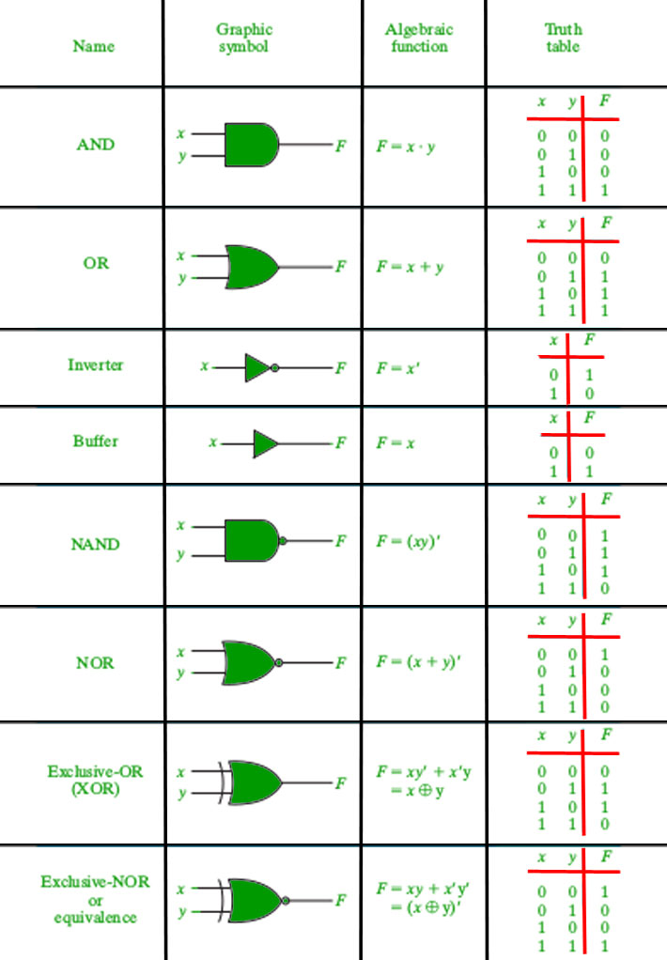

M2- Mention the universal logic gates?
Ans : NAND and NOR

- explain fourier transform to a layman
You remember that experiment we took in school, where we pass a beam of white light through a prism and we see all the different colors on the other side. This is what Fourier Transform does. The white light is the input signal consisting all the frequencies. The prism is the Fourier Transform operation and the output contains all the frequency contents of the signal.
Other way : By wearing some goggle we are able to extract information, which was earlier impossible. Hence, In some cases, when we can’t see things in bare eyes(time domain) we use Fourier goggles to extract information. And our mathematicians have developed many goggles to view our world. Ex : Laplacian, Hilbert, Taylor goggles. We use them based on what we want to extract, in this analogy its distance, may be harmonic frequency from Fourier goggles.
We see the same objects in both views. i.e. time or frequency view. Only the type of information varies.
- uses and types of flip flops
Flip flops are used as data storage elements.
- benefits of digital communication
- The digital communication is fast, easier and cheaper
- Much less bulky than analog equivalent
- It can be done over large distances through internet devices and other things
- The error may offer to be corrected with the use of coding

Digital electronics fav question
1.Difference between Analog signal and Digital Signal
ANALOG COMMUNICATION | DIGITAL COMMUNICATION
Analog communication uses analog signal whose amplitude varies continuously with time from 0 to 100. | Digital communication uses digital signal whose amplitude is of two levels either Low i.e., 0 or either High i.e., 1.
It gets affected by noise highly during transmission through communication channel. | It gets affected by noise less during transmission through communication channel.
In analog communication error Probability is high. | In digital communication error Probability is low.
In analog communication noise immunity is poor. | In digital communication noise immunity is good.
In analog communication coding is not possible. | In digital communication coding is possible. Different coding techniques can be used to detect and correct errors.
Separating out noise and signal in analog communication is not possible. | Separating out noise and signal in digital communication is possible.
Analog communication system is having complex hardware and less flexible. | Digital communication system is having less complex hardware and more flexible.
Analog communication system is low cost. | Digital communication system is high cost.
2. What is RADAR
Radar is a detection system that uses radio waves to determine the distance, angle, or velocity of objects.

Parameters of Comparison | Radar | Sonar
Definition | Same principle | Uses same principle
Full forms | Radio detection and ranging device. | Sound ranging and navigation device.
Wave Type | Radio waves, hence long distance. | Uses sound waves, hence short distance
Usually used | Radar is mostly used in space, spacecraft, and aeroplanes, etc. | Sonar is mostly used under the water for communication purposes and ranging purposes etc.
Frequencies | 50-330MHz | 100KHz-1Mhz

4. Explain CRO
A Cathode Ray Oscilloscope (CRO) is an instrument generally used in a laboratory to display, measure and analyze various waveforms of electrical circuits. A cathode ray oscilloscope is a very fast X-Y plotter that can display an input signal versus time or another signal
P: Design a 4 bit adder
Drew the circuit using different logic gates
P: Design it only using nand gates
P : Is this the optimal design or it can be optimised
Told analog electronics
P : Do you know about capacitor?
A capacitor is a device that stores electrical energy in an electric field. It is a passive electronic component with two terminals.
P: Can a capacitor change the frequency in the circuit ?
Capacitor alone doesn't change the frequency. It works in conjunction with a coil or inductor. Together they form a resonance circuit, either series or parallel and get tuned to frequency on demand.
M - you know about diode?
A diode is a device that allows current to flow in one direction but not the other. This is achieved through a built-in electric field.
M - Different types of diodes
M - difference between LED and Zener Diode
- diode- blocks current if reversed
- zener diode- maintain a constant voltage if reversed
- led- nothing if reveresed, in forward bias it emits light
M - LED is made up of Answered in layman terms
it depends on the chemicals we use for different light colours, we use different chemicals
M – LCD vs LED vs Plasma vs OLED
LCD – Liquid Crystal Display in front – At the back, it uses fluorescent light(Cold Cathode Fluorescent Lamps - CCFLs). Because we cant switch off the light, we cant see complete black, and it looks greyish.
LED – Same as LCD, but at the back end, we use LED light. So we can switch off light for certain parts and black looks better. Makes the TV slimmer, and LED consumes less power as well.
OLED – Tech changes. There is no backlight, each pixel has its own light. Very expensive. Each pixel black can be individually controlled, hence complete black.
Quantum Dot TVs – Display panel is made up of Quantum dots, where the color display is absolutely fantastic.
M - At what voltage led works
Below 5 Volts (BW 1.2 to 3.6 Volts)
M - Colour coding of Resistor
M - why gold and silver colours are used?
M - value of gold colour
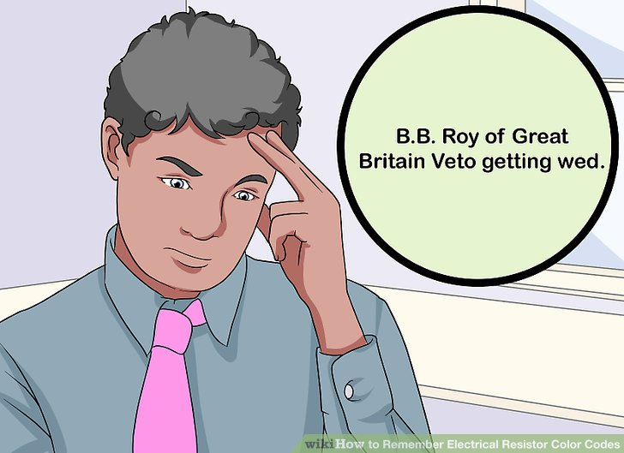

0 1 2 3 4 5 6 7 8 9
Black brown Red Orange Yellow Green Blue Violet Grey White Silver Gold

Gold and silver are the indicators for the most common tolerances: gold 5% and silver 10%. And the tolerance is the the most right ring in the resistance color coding schema.
4 bands:

Red Orange Green Silver
23*10^5 with 10 percent tolerence

SET3
- What are Flip flops and explain their working?
- Differentiate between flip-flops and latches.
- What is the mode of transmission of TV signals?
- What is a bit?
- What are logic gates made up of?
- AM vs FM
- Explain the operation of a zener diode.
- What is avalanche breakdown? When does it occur?
- What is Zener breakdown?
- Obtain a square wave from a sine wave form Zener diodes.
- What is blue tooth and WAP?
- What is the difference between half adder and full adder?
- What is Karnaugh map?
- What is metastable state in flip-flops?
Whenever there are setup and hold time violations in any flip-flop, it enters a state where its output is unpredictable: this state is known as metastable state.
- What is universal flip flop? JK flip flop.

- What is sampling?
- What is the mathematics used in DSP and from which domain to which domain is signal converted?

- What is packet switching and circuit switching?
- Explain different types of switching.
- What is VOIP (Voice over Internet Protocol)?
- What is round robin technique of interrupt arbitration?
- What types of communications do you know?
- Explain various types of digital communication.
- What is the protocol used in telephone network?

- Explain the structure of MOSFET - where and why they are preferred.
- How is amplification possible in a transistor?
- Classify power amplifiers (A, B, AB).
- What is doping?

- What is modulation? What are the different modulation techniques?
- What is FM, PM and AM? Compare the three and what happens in them?
- Which waves will travel longer distance - FM or AM?

- What are VLSI and ULSI? What is the number of components in both?
- How many components are there in the Pentium processor that we use?
- Which is the latest Pentium processor? What is its speed?
- Explain the technology used in the manufacture of Pentium processor.
- Explain asynchronous and synchronous counter.
- How does a diode look (internally)? Explain working using internal diagram.
- Explain processes taking place in the depletion junction of a forward biased diode
- What is a buffer? what is the gain of a buffer?
- How do you forward bias a transistor?
- What are the practical applications of transistors?
- What is reverse recovery time and how does it affect a diode?
- What is a compiler?
- What is VHDL?
- What is FSF? What do you know about it? Any current relevance?
- Difference between intrinsic and extrinsic semiconductor.

- Volume control in TV is logarithmic. Why?

- Difference between NPN vs PNP.
NPN | PNP
The current flows -collector terminal to emitter terminal. | The current flows -emitter to collector terminal.
collector is +ve voltage. | emitter terminal a +ve voltage.

